CITE

30003389

Database Programming AT3

Data Dictionary

Table of Contents

Database Design 1

Customer 2

Invoice 3

Employee 4

Invoice_Line 5

Product 6

Category 7

Supplier 8

# Database Design

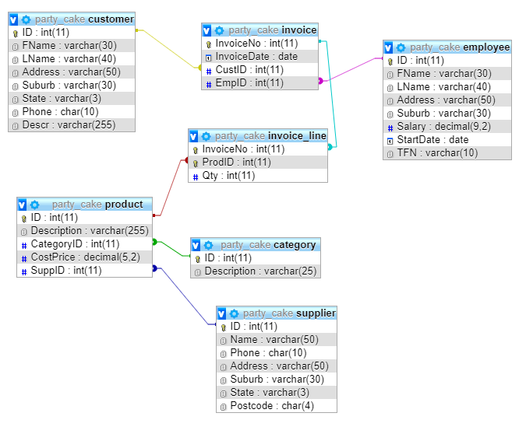

# Customer

|  |  |  |  |  |  |  |
| --- | --- | --- | --- | --- | --- | --- |
| Field Name | Description | Data Type | Length/Size | Acceptable Values | Required? | Accept Null Values? |
| ID | ID number for data | INT | N/A | Auto Increment | Y | N |
| FName | Customer First Name | VARCHAR | 30 | Bob, Michael | N | Y |
| LName | Customer Last Name | VARCHAR | 40 | Sanders, Remming | N | Y |
| Address | Customer Address | VARCHAR | 50 | 3 Woodstock Pl | N | Y |
| Suburb | Customer Suburb | VARCHAR | 30 | Bentley, Perth | N | Y |
| State | Customer State | VARCHAR | 3 | WA, NSW | N | Y |
| Phone | Customer Phone Number | CHAR | 10 | 0415658478 | N | Y |
| Descr | Customer Description | VARCHAR | 255 | Normally orders cheesecakes | N | Y |

# Invoice

|  |  |  |  |  |  |  |
| --- | --- | --- | --- | --- | --- | --- |
| Field Name | Description | Data Type | Length/Size | Acceptable Values | Required? | Accept Null Values? |
| InvoiceNo | Invoice ID | INT | N/A | Auto Increment | Y | N |
| InvoiceDate | Date of Invoice | DATE | N/A | 06/05/2018 | N | Y |
| CustID | Customer ID | INT | N/A | Auto Increment | Y | N |
| EmpID | Customer ID | INT | N/A | Auto Increment | Y | N |

# Employee

|  |  |  |  |  |  |  |
| --- | --- | --- | --- | --- | --- | --- |
| Field Name | Description | Data Type | Length/Size | Acceptable Values | Required? | Accept Null Values? |
| ID | Employee ID | INT | N/A | Auto Increment | Y | N |
| FName | Employee First Name | VARCHAR | 30 | Harry, Zelda | N | Y |
| LName | Emplye Last Name | VARCHAR | 40 | King, Charlesworth | N | Y |
| Address | Employee Address | VARCHAR | 50 | 2/4 Bird St | N | Y |
| Suburb | Employee Suburb | VARCHAR | 30 | Kingsley, Victoria Park | N | Y |
| Salary | Employee Salary | DECIMAL | 9,2 | 55000.00 | N | Y |
| StartDate | Employee contract start date | DATE | N/A | 05/02/2017 | N | Y |
| TFN | Employee Tax File Number | VARCHAR | 10 | 3546871547 | N | Y |

# Invoice_Line

|  |  |  |  |  |  |  |
| --- | --- | --- | --- | --- | --- | --- |
| Field Name | Description | Data Type | Length/Size | Acceptable Values | Required? | Accept Null Values? |
| InvoiceNo | Invoice ID | INT | N/A | Auto Increment | Y | N |
| ProdID | Product ID | INT | N/A | Auto Increment | Y | N |
| Qty | Quantity of Items Purchased | INT | N/A | 10, 18 | N | Y |

# Product

|  |  |  |  |  |  |  |
| --- | --- | --- | --- | --- | --- | --- |
| Field Name | Description | Data Type | Length/Size | Acceptable Values | Required? | Accept Null Values? |
| ID | Product ID | INT | N/A | Auto Increment | Y | N |
| Description | Description of Product | VARCHAR | 255 | Chocolate Cark | N | Y |
| CategoryID | Category ID | INT | N/A | Auto Increment | Y | N |
| CostPrice | Cost of Product | DECIMAL | 5,2 | 315.55 | N | Y |
| SuppID | Supplier ID | INT | N/A | Auto Increment | Y | N |

# Category

|  |  |  |  |  |  |  |
| --- | --- | --- | --- | --- | --- | --- |
| Field Name | Description | Data Type | Length/Size | Acceptable Values | Required? | Accept Null Values? |
| ID | INT | INT | N/A | Auto Increment | Y | N |
| Description | VARCHAR | VARCHAR | 25 | Cake, Cupcake | N | Y |

# Supplier

|  |  |  |  |  |  |  |
| --- | --- | --- | --- | --- | --- | --- |
| Field Name | Description | Data Type | Length/Size | Acceptable Values | Required? | Accept Null Values? |
| ID | Supplier ID | INT | N/A | Auto Increment | Y | N |
| Name | Supplier Name | VARCHAR | 50 | Kingsley Bakery | N | Y |
| Phone | Supplier Phone Number | CHAR | 10 | 0402568745 | N | Y |
| Address | Supplier Address | VARCHAR | 50 | 3 Goodley Cres | N | Y |
| Suburb | Supplier Suburb | VARCHAR | 30 | Nollamara | N | Y |
| State | Supplier State | VARCHAR | 3 | WA, QLD | N | Y |
| Postcode | Supplier Postcode | CHAR | 4 | 6015 | N | Y |